**LAB 1 week 4**

**Tutorial to Install the IDE(BlueJ)**

# **Install BlueJ**

* 1. visit the following websites

<https://www.bluej.org/>

* 1. choose the appropriate version according to your operating system.

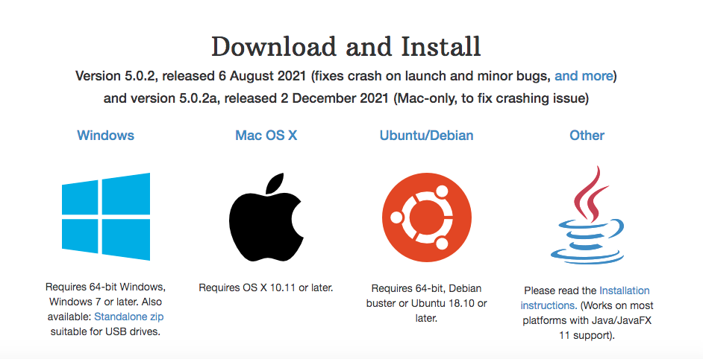

2.3 Once BlueJ is downloaded, open the BlueJ folder, and click on the BlueJ icon.

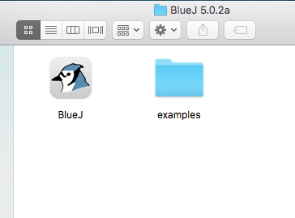

2.4 When BlueJ is up and running you should see a window that looks something like this:

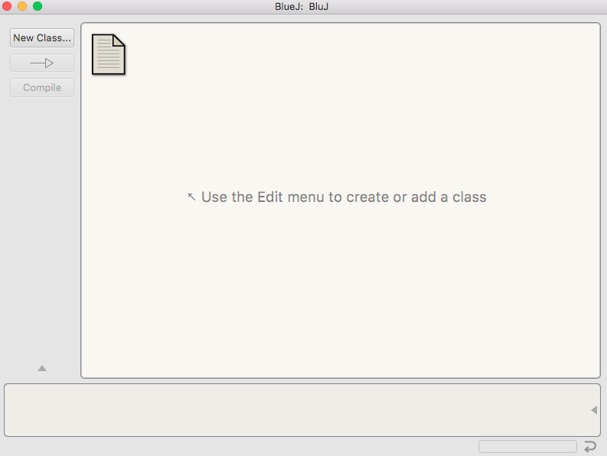

# **Starting BlueJ**

# 3.1 To create a new program you first need to create a new project. Click on the **Project** menu and select **New Project.**

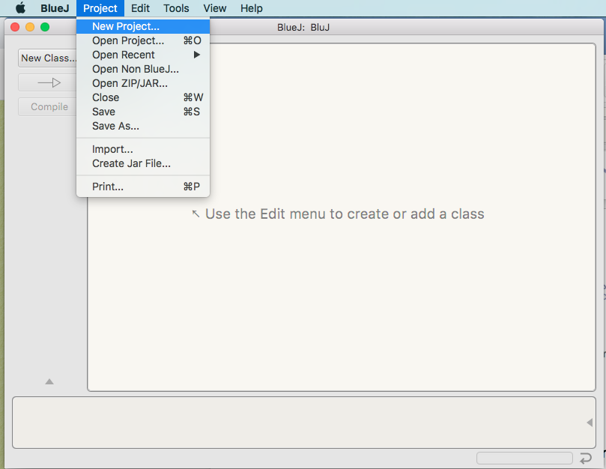

3.2 This open new window, from this window type name of your project and select the location in your machine to save the project. As a good practice, you can create a specific folder for all your java programs on the desktop then create a sub folder for each project.

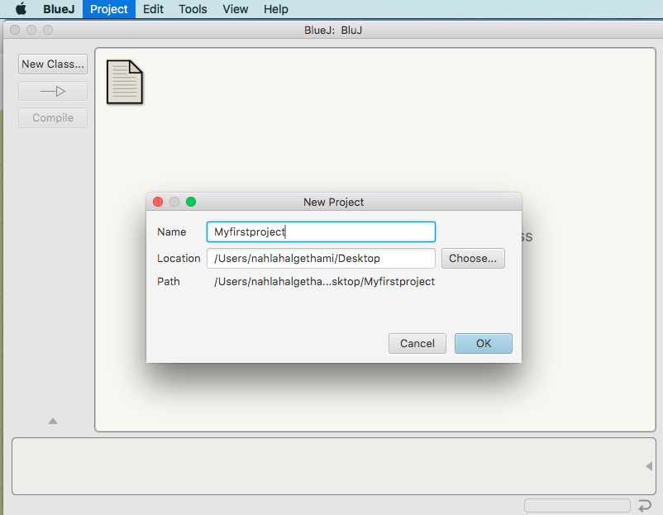

3.3 After creating the new project, you can see the following window. The icon that look like a piece of paper is just a simple text file that acts as the projects readme file. There are not any classes which are the basic building blocks for any java application.

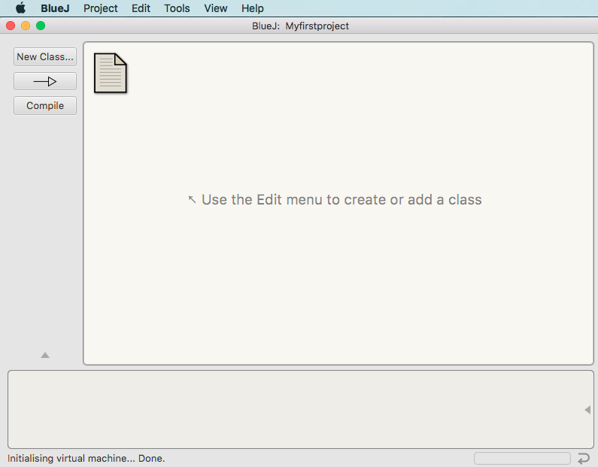

3.4 To add a new class to the project click on the New **Class** button. Write Welcom in the Class Name then click OK.

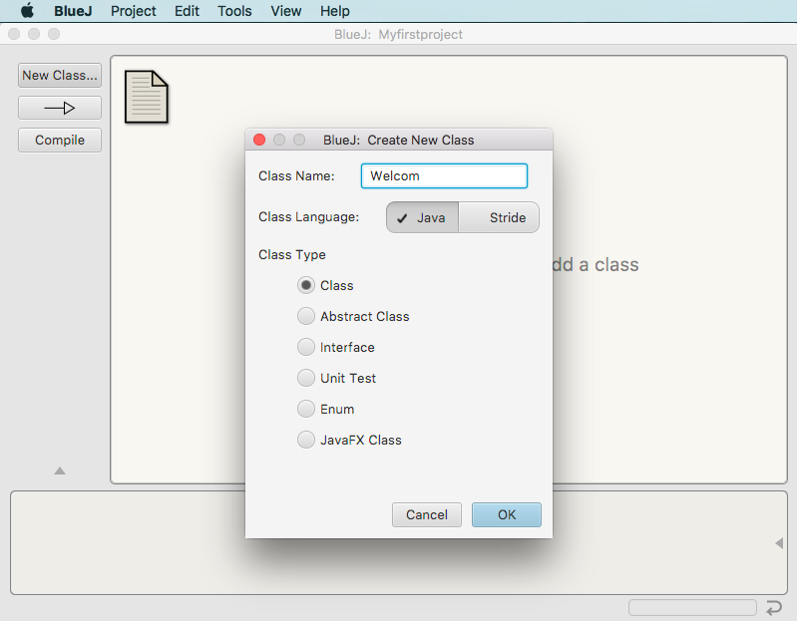

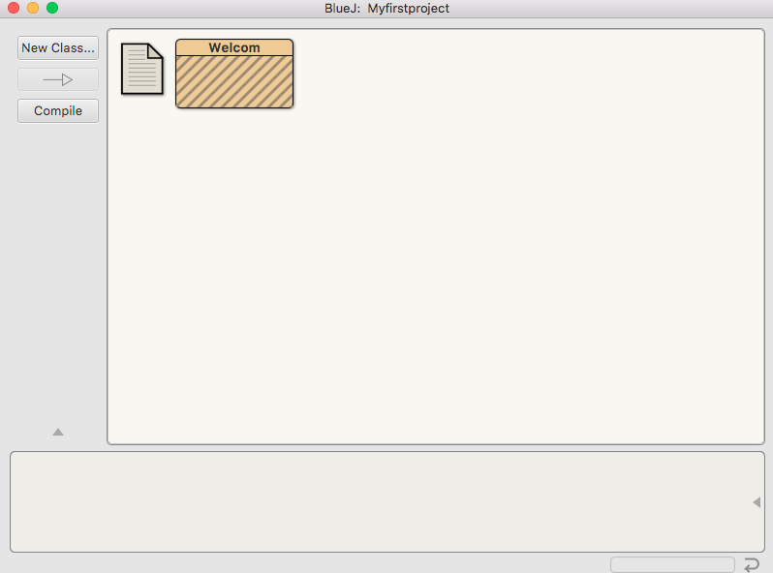A new box with the name of the class appear in the project window as shown in the following figure

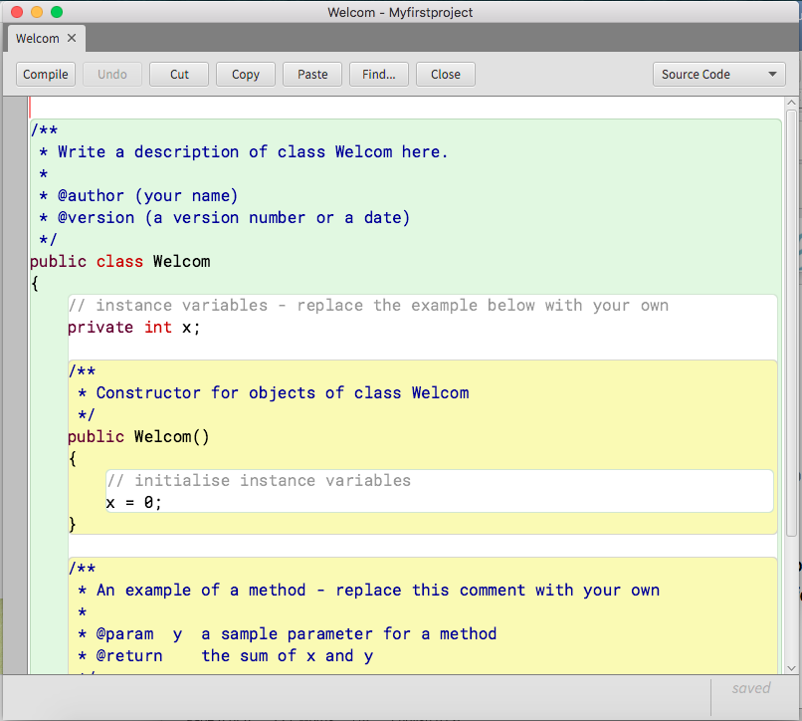3.5 To edit the code in a class double click on its icon. This opens an editor window as the following.

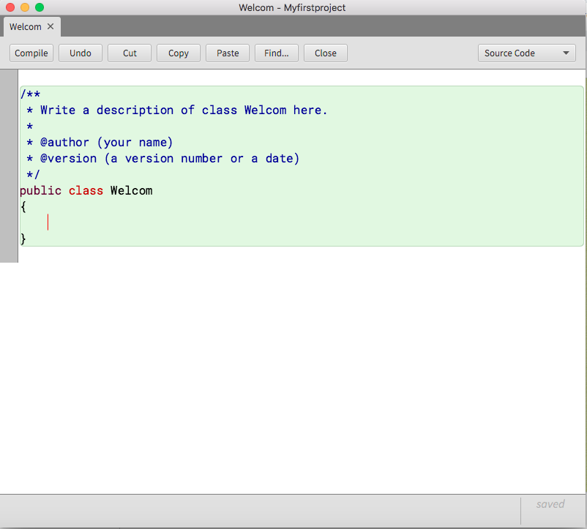3.6 Select and delete the default code in the class.

3.7 copy and paste the following code **inside** the class Welcom

// main method begins execution of Java application  
 public static void main(String[] args)  
 {   
 System.out.println("Welcome to Java Programming!");  
   
 } // end method main   
your program look like as the following

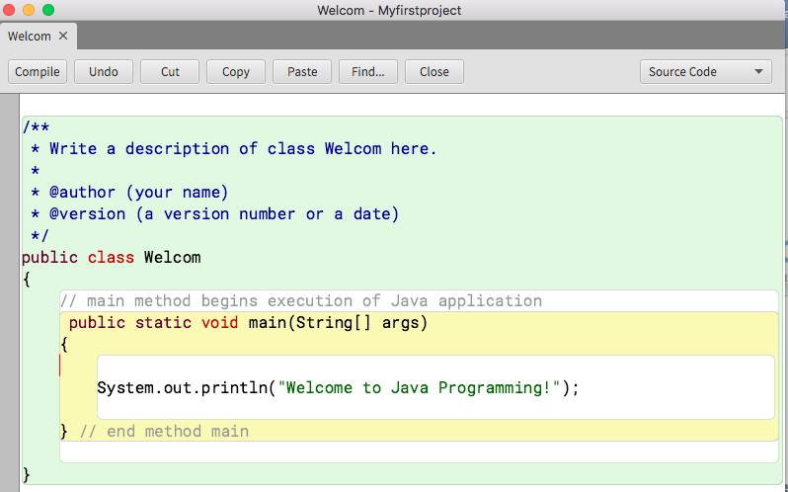

**Note:** The Name of the class must be same as the name of .java file.

3.8 In order to run your first java application, firstly you need a compiler to convert high-level language programs into machine language*.* This is done by clicking on the **Compile** button on the top side of the window. If there are no syntax errors, the compiler produces a **.class** file called Welcom.class (bytecodes). You can open the project location in order to visualize the files (Welcom.java and Welcom.class)

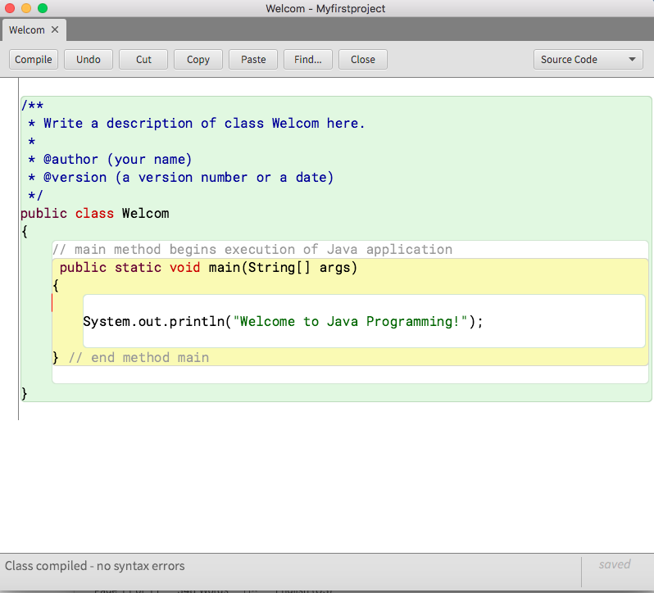

3.9 To run the program right click on the class that has the main method in it. You could also compile classes here.

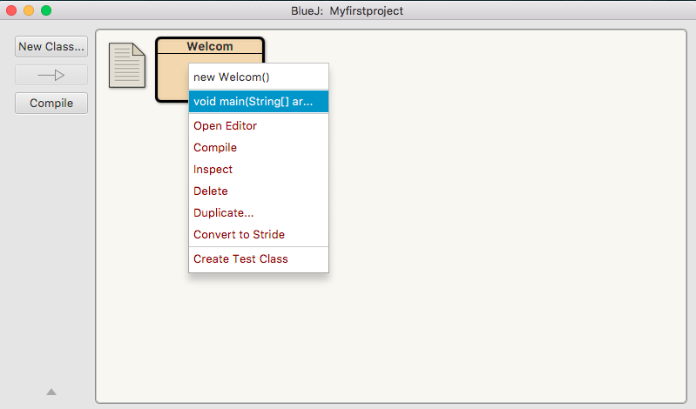

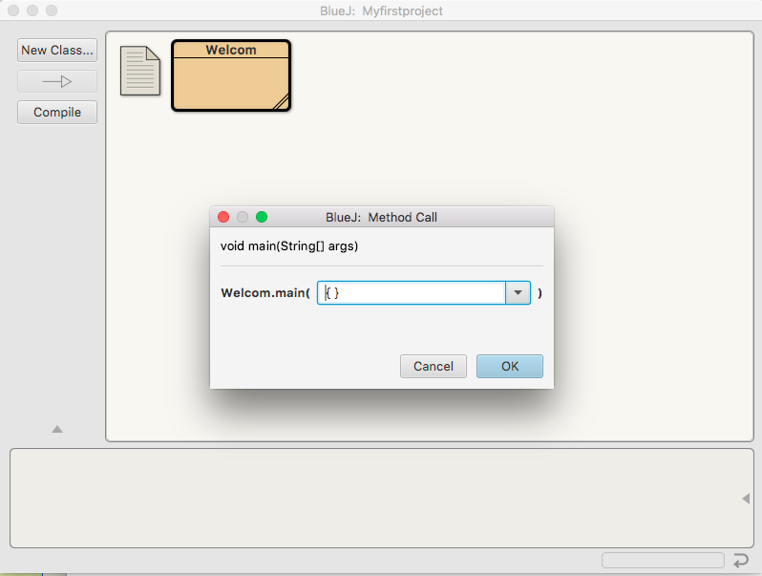

The below image show the obtained output after running the program.

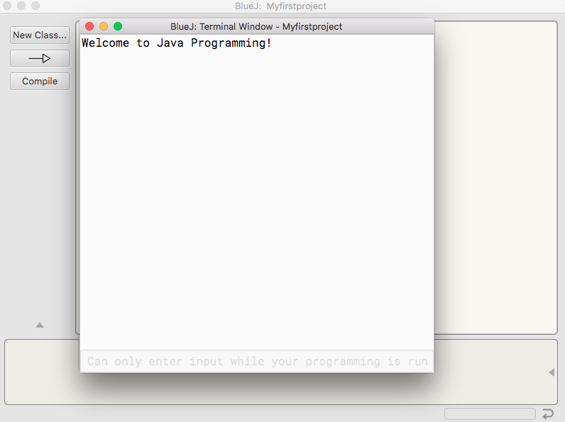

References: https://www.cs.utexas.edu/users/scottm/cs307/handouts/BlueJProjectInstructions.html